Shipt - QA Engineer - Interview Exercise

Upon completion of this exercise, push all your files into github and send us a link.

1. Navigate to www.shipt.com. Choose a feature of the site and write a description or test
case to describe how to test the feature.

Feature: SignUp
Title: Sign up new user
Description: All signup link should lead to same page
    - Go to www.shipt.com , click on “SignUp” button and enter “email-id” and “zipcode”
Expected: Validate email-id, email should be valid format, also check in the DB if email already exists
Validate “ZipCode” format, also check in the DB if serving in that ZipCode Area
Click on “Go”
    - Choose plans
        - Choose one of the available plan
Expected: Validate it navigates to the right page, say account info and payment info page
    - Enter account and payment info
Expected: Validate all the fields
    - Click on “Start Membership”
Expected: Validate user account has created with all information created in above steps.

2. Locate one bug or bad workflow within the app.
a. Explain the behavior you are seeing
b. Include any useful errors or screenshots
c. Explain why or how it needs to be corrected
d. What are the steps you would take to report the issue?

Bug1: Signup button from two different links are leading to two different sign up pages
Description:
    - Click “SignUp” button on home page, this leads to user friendly SignUp page
    - Click on “Login” button, in login page click on “SignUp” button. This leads not so user friendly “SignUp” page
Expected: SignUp button on both the pages should lead to same page
Actual: SignUp button on both the pages leading to different pages and difficult to test/development/user

Bug2: “SignUp” page from “LoginPage” is not indicating user about the “Mandatory Fields”.
Description:
    - Click on “Login” button, in login page click on “SignUp” button.
    - Enter all the information except “Phone Number”
    - Click on “Create Account” button
Expected: Some notification/indication saying that “Phone Number” is mandatory
Actual: There is no notification/indication to the user

PS: There are lot of bugs

3. What priority would you give this bug (Scale of 1-5, 1 being highest) and why?

Priority – 3/Medium
Why → 1. Confusing the User
2. Difficult to develop, maintain, test two different pages

4. In the database, you have the following tables (columns listed on each)
a. How would you define the relationships between each table? (1 to many, many to
many, 1 to 1)
b. Write a SQL query which would return the ID and Store of an order tied to a
specific Customer and Shopper

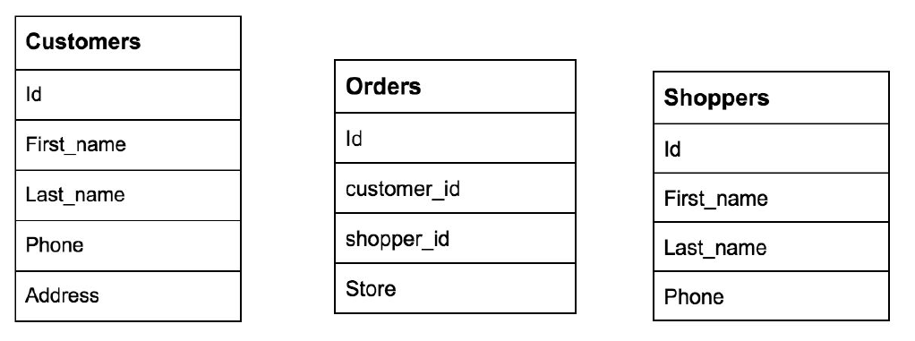
a. Relationships between table: “Many to Many“, because Orders table is junction table. Which has primary key “id” from both “Customer” and “Shoppers” table.
b. Select Orders.ID, Orders.Store
from Customers INNER JOIN(Orders
INNER JOIN(Shoppers
on Orders.shopper_id=Shoppers.id)
on Customers.id=Orders.customer_id)
ORDER BY Orders.id

Automation

Write an automated test which accomplishes the following
1. Access www.shipt.com in the browser
2. Using the feature you chose for step 1, write an automated test
3. The test should validate the feature works as expected

Code has checked in to https://github.com/UshaSarathiB/ShiptInterviewAssesment

We recommend you choose from the following languages/tools. Feel free to use other tools if
you feel they lend better to this type of testing.
● Selenium
● Calabash
● Typescript/Javascript
● Ruby

Automation Assessment

1. If you chose to use a tool or language other than the recommended, briefly explain why.

Using Selenium with Python

2. How did you go about locating the elements for your tests?

By using FireBug/FirePath/Inspect Element options in Mozilla and Chrome

3. What do you believe are the most common causes for instability in UI automation?

a. Timing issues is one of the major cause in UI automation
b. When there is no right exception handling

4. How do you make your tests consistent and easy to debug?

a. Using TestFrameworks which suites for project
b. By adding more debug/logs/comments in the code
c. Also, can use in-build docs like python-doc-strings, JavaDoc, etc with respect to languages

